**EE 525 – Assignment 2**

**Tanmay Gore -** [**Tgore03@iastate.edu**](mailto:Tgore03@iastate.edu)

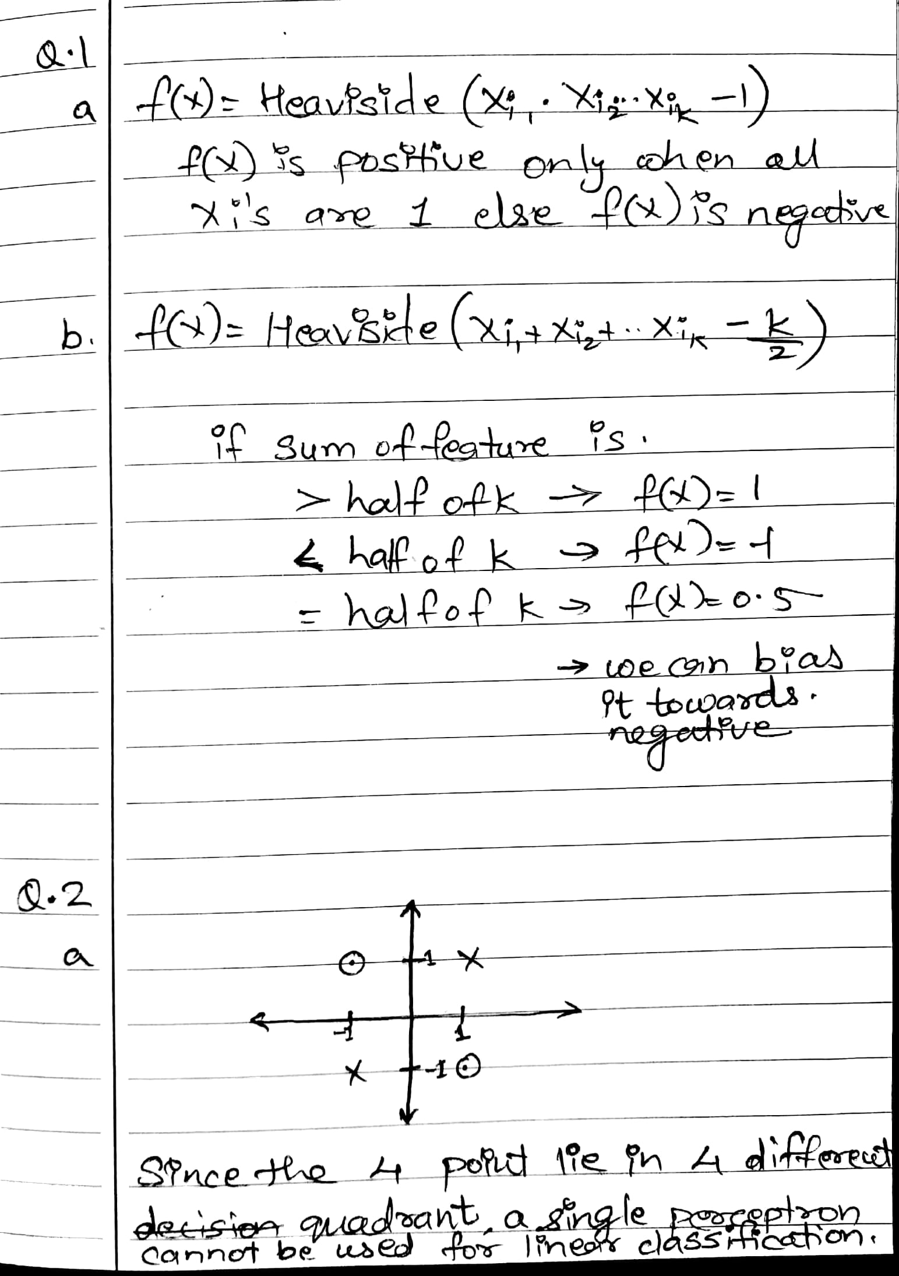

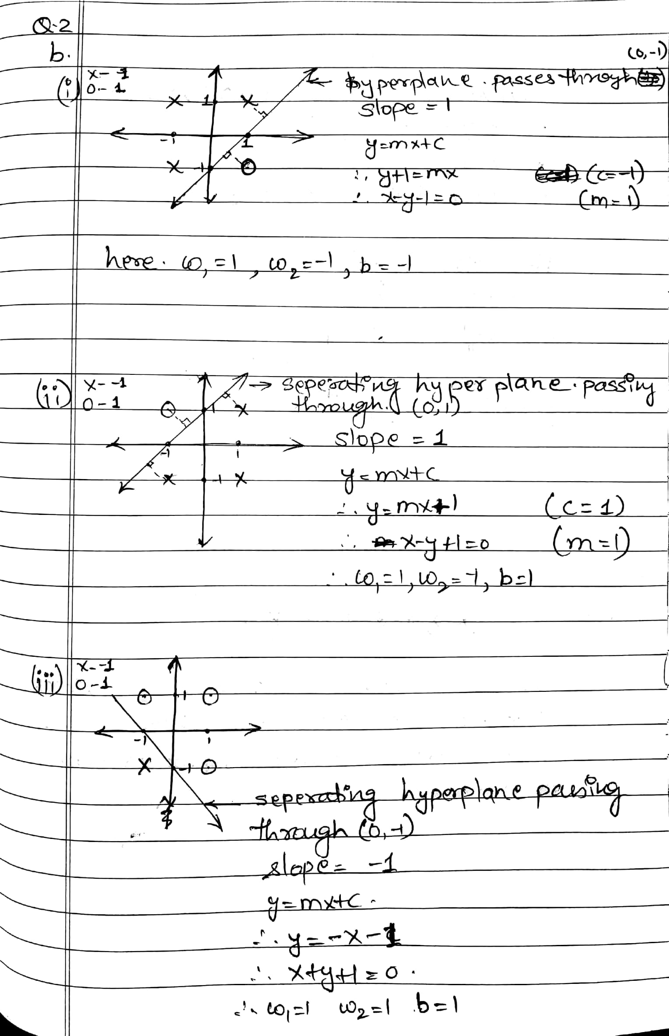

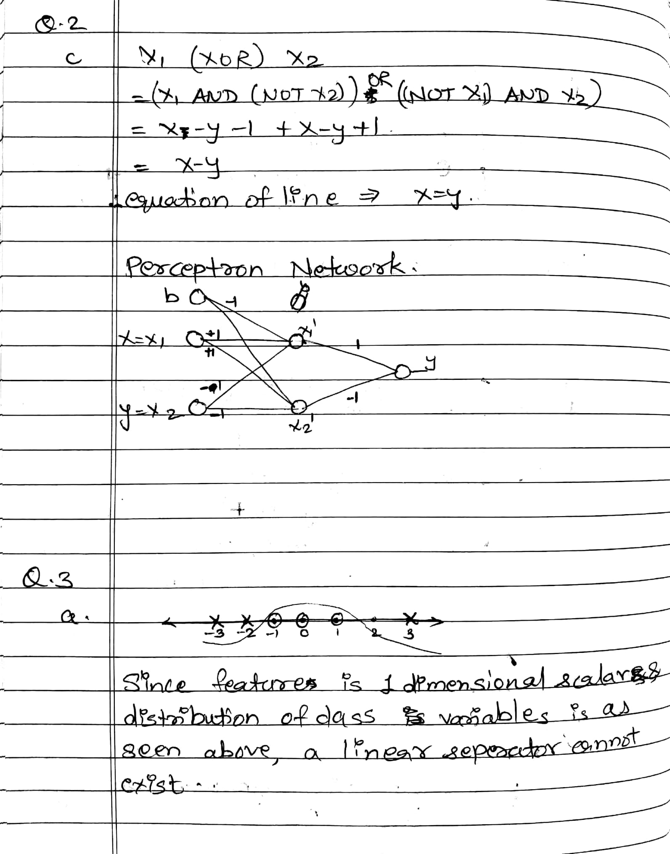

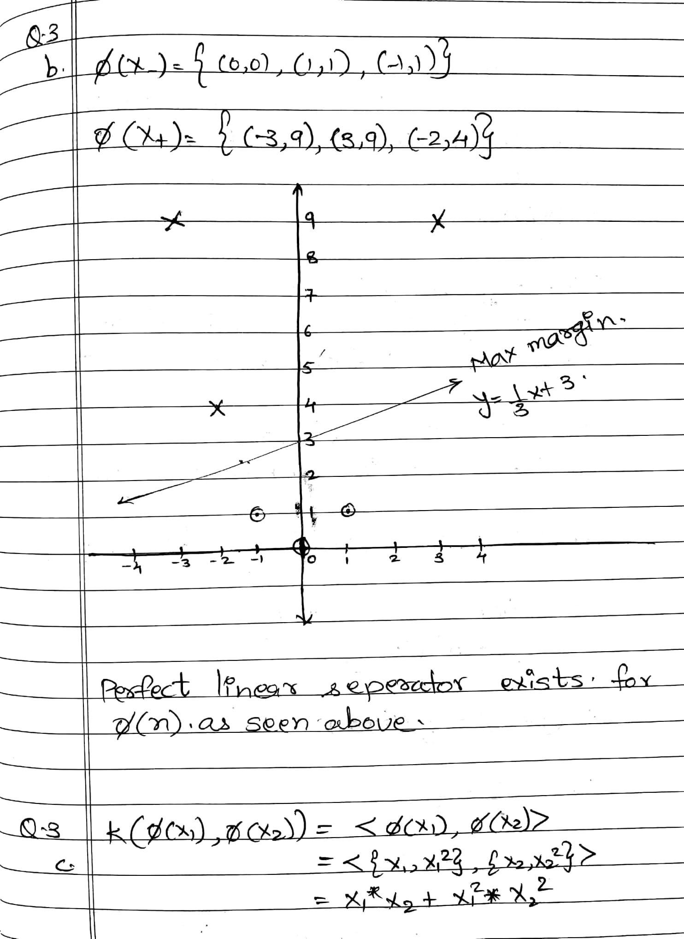

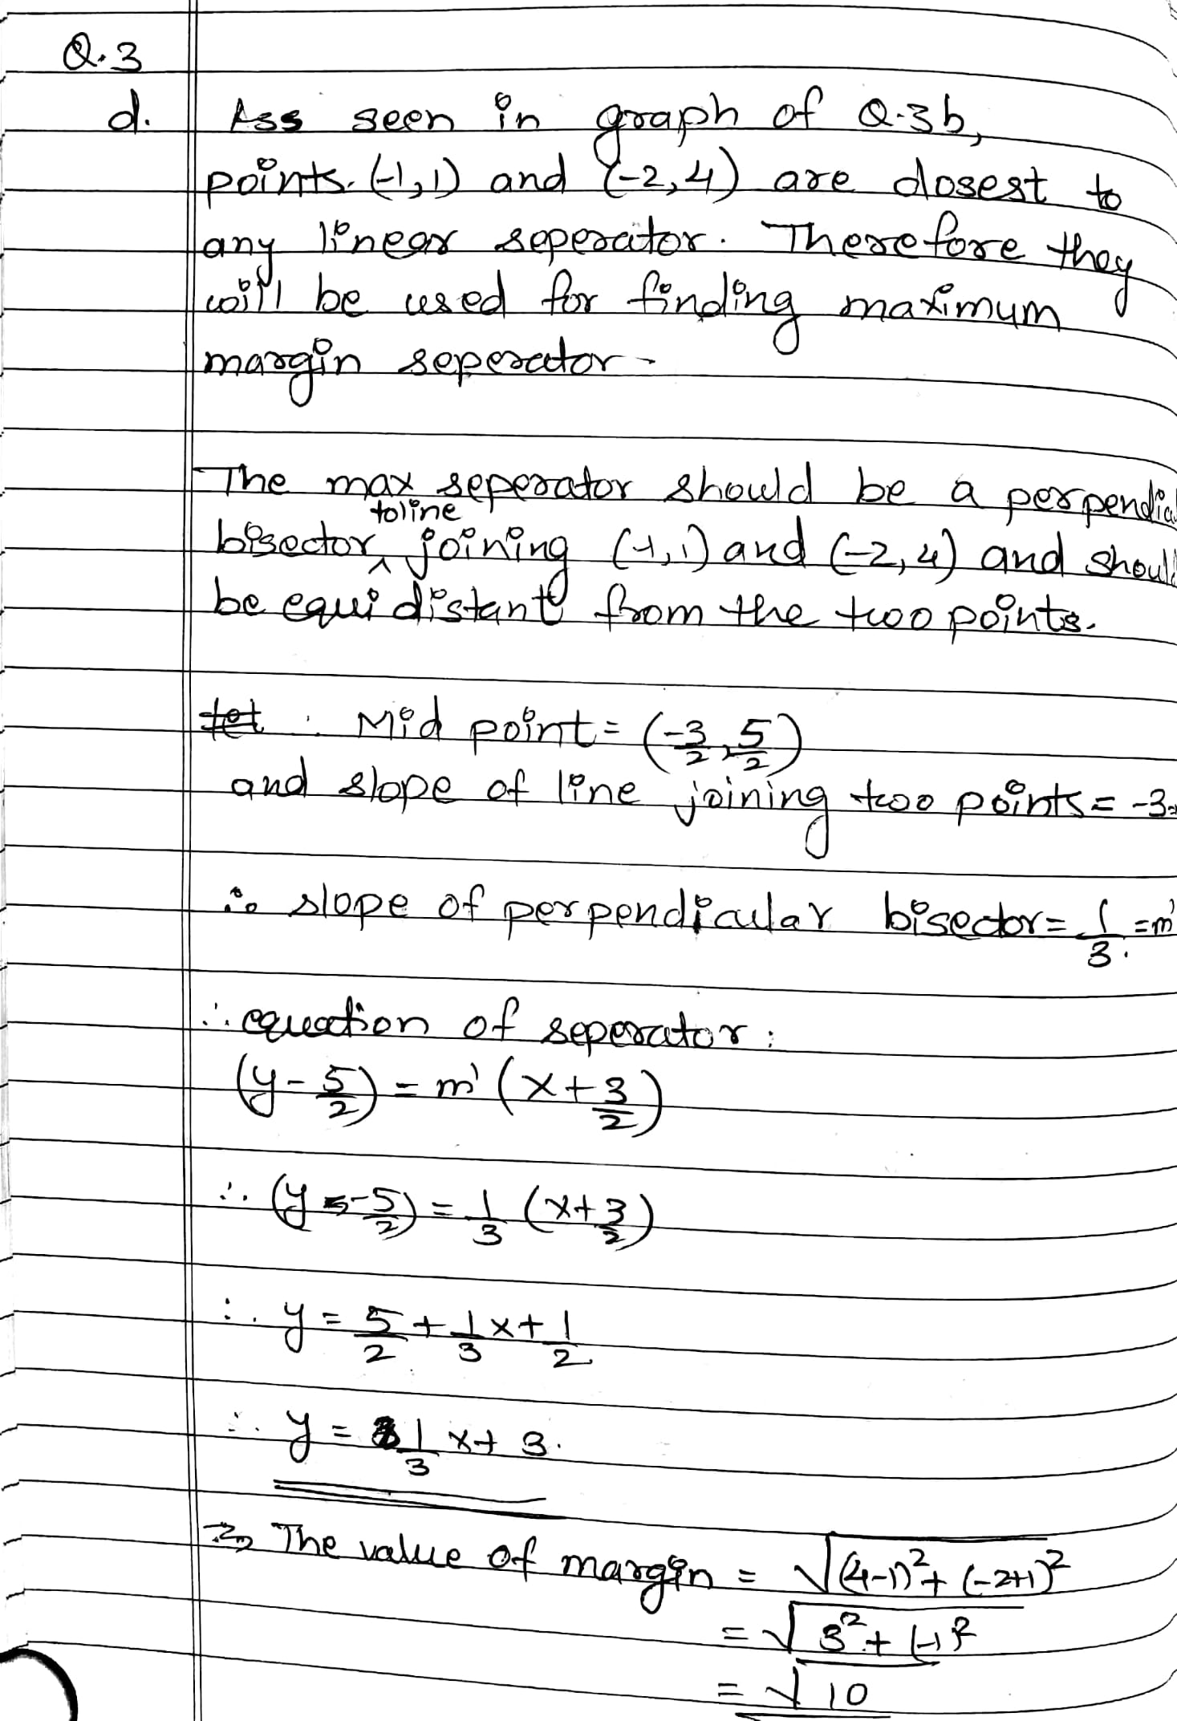

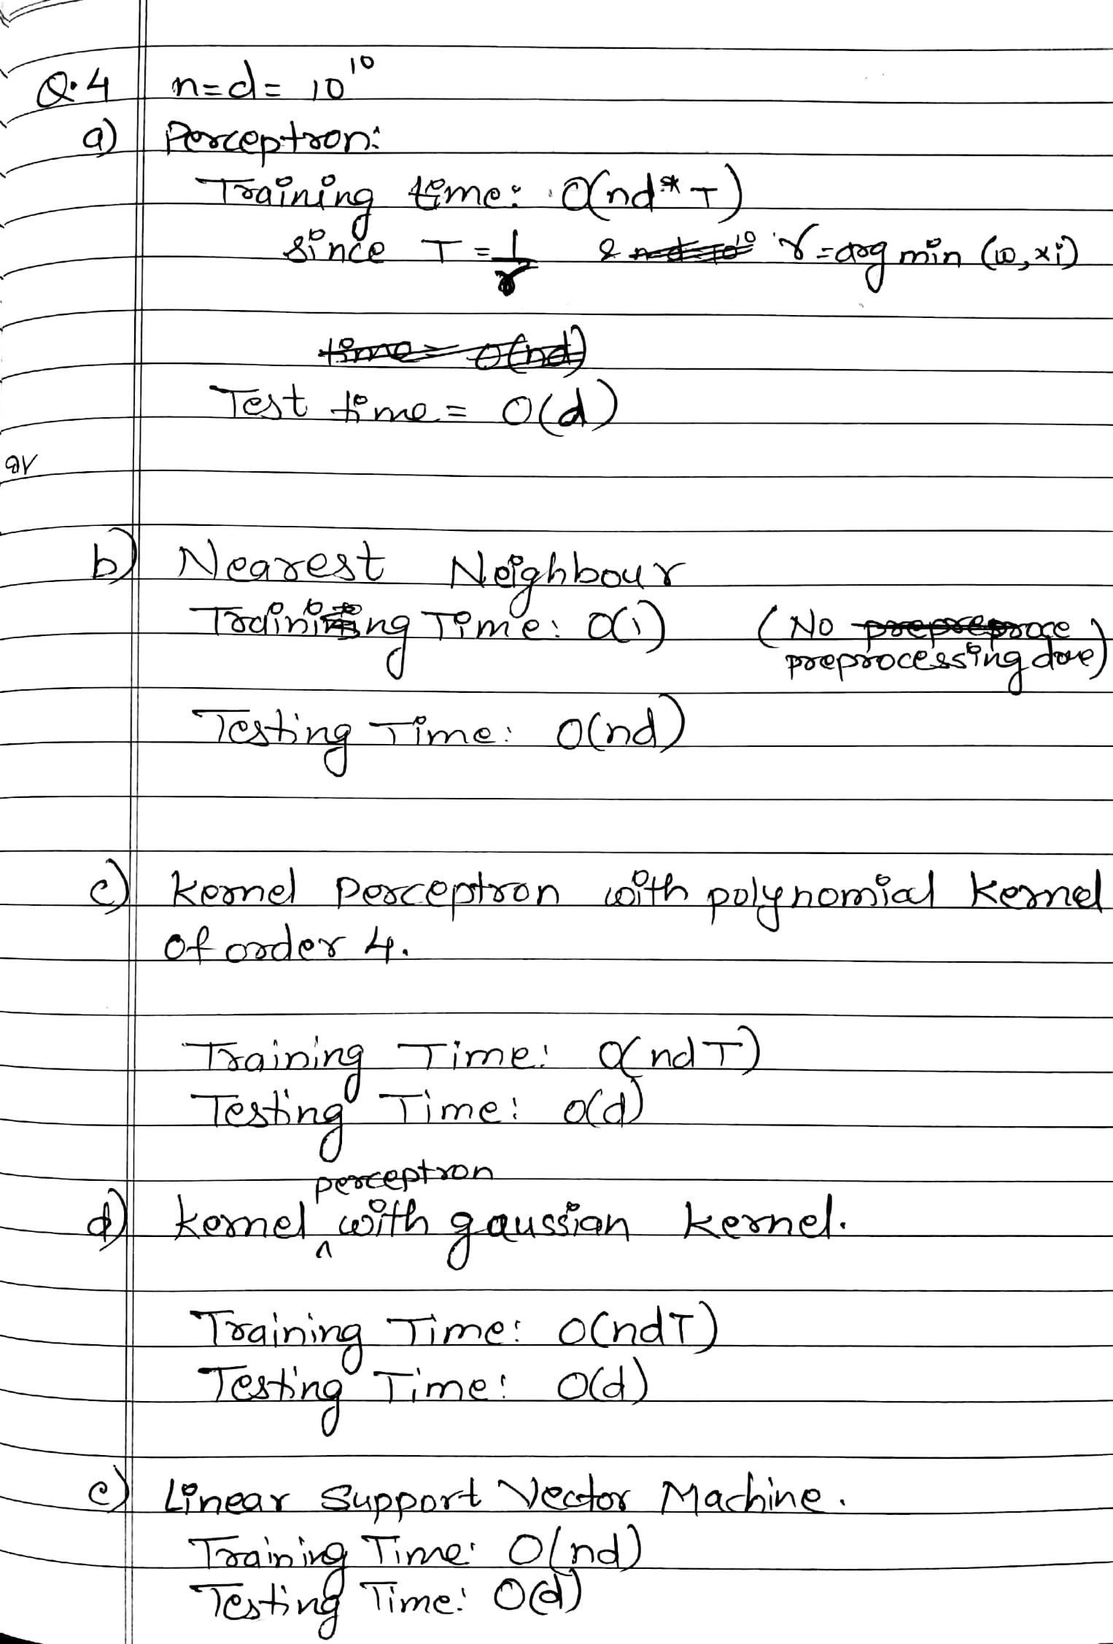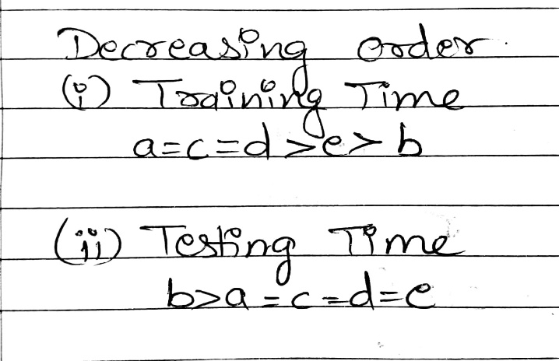

Q5)

KNN – Without Normalization

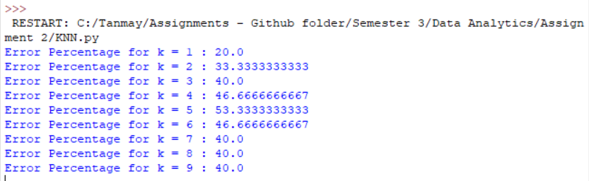

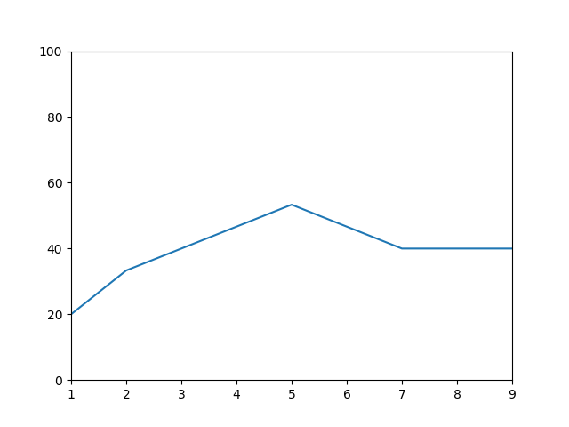

**Code:**

import csv

import numpy as np

import random

from sklearn import neighbors

import sys

import matplotlib.pyplot as plt

#Variable definition

CLASS1 = 59

CLASS2 = 71

CLASS3 = 48

totalrecords = 178

train_rows = (CLASS1-5)+(CLASS2-5)+(CLASS3-5)

train_cols = 13

global train_data, train_label, test_data, test_label, label, data

global knn, wrong_class, neighbors, error

def main():

#readcsv data

data = np.genfromtxt('wine.data.csv', delimiter=',')

label = data[:, 0]

data = data[:,1:]

#train data

global wrong_class, neighbors, error

error=[0]*10

splitdata(data, label)

for i in range(1,10):

train_model(i)

#predict data label

iter_no = 100

wrong_class=0

predict_label(i, iter_no)

error_prob(i, 15, iter_no)

plot_error()

def plot_error():

plt.plot(error[:])

plt.axis([1, 9, 0, 100])

plt.show()

def error_prob(k, total_data, iter_no):

global wrong_class, error

error[k] = (wrong_class / (total_data*iter_no)) * 100.0

print "Error Percentage for k =",k,":", error[k]

def predict_label(k, iter_no):

global test_data, test_label

global knn, wrong_class

for i in range(iter_no):

#result = KNN(k)

result = knn.predict(test_data)

for i in range(0, len(result)):

if(result[i] != test_label[i]):

wrong_class+=1.0

def train_model(k):

global train_data, train_label

global knn

#Train Model

knn = neighbors.KNeighborsClassifier(n_neighbors = k, algorithm='kd_tree')

knn.fit(train_data, train_label)

def splitdata(data, label):

global train_data, train_label, test_data, test_label

train_data = data

train_label = label

test_data = np.empty([15, train_cols])

test_label = np.empty([15, 1])

no1 = random.sample(range(0, 59-1), 5)

no2 = random.sample(range(59, 130-1), 5)

no3 = random.sample(range(130, totalrecords-1), 5)

no4 = no1 + no2 + no3

train_data = np.delete(train_data, (no4), axis=0)

train_label = np.delete(train_label, (no4), axis=0)

i=0

for no in no4:

test_data[i] = data[no]

test_label[i] = label[no]

i+=1

main()

def calc_EHdist(train_row, test_row):

dist=0.0

for i in range(0, len(train_row)):

dist += pow((train_row[i]-test_row[i]),2)

#print dist

return dist

def kneighbors(min_val, dist, row_index, k):

largest=0.0

#print min_val

index=0

for i in range(0,k):

if min_val[i][0] > largest:

largest = min_val[i][0]

index = i

if min_val[index][0] > dist:

min_val[index][0] = dist

min_val[index][1] = row_index

return min_val

def KNN(k):

#compute manhattan distance between test data and training data

global test_data, train_data

result = []

#For each test record

for test_row in test_data:

#argmin of manhattan distance

min_val=[]

for i in range(0,k):

if(i==0):

min_val=[[sys.float_info.max,0]]

continue

min_val.append([sys.float_info.max, 0])

row_index=0

for train_row in train_data:

dist = calc_EHdist(train_row, test_row)

min_val = kneighbors(min_val, dist, row_index,k)

row_index+=1

#return max label

a, b, c = 0,0,0

for minv in min_val:

label = train_label[minv[1]]

if label == 1:

a+=1

elif label == 2:

b+=1

else:

c+=1

print a,b,c

if (a>=b & a>=c):

result.append(1)

elif (b>a & b>=c):

result.append(2)

else:

result.append(3)

return result

Q.7)

Time spent = 12 hours

**Acknowledgement**: Discussed with Nitesh Gupta.